Safe Ministry Training Course
New Users

- Go to website & create an account.
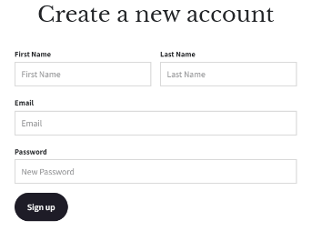
https://etraining.safercommunities.net.au/users/sign_up

- Enroll in and complete training.
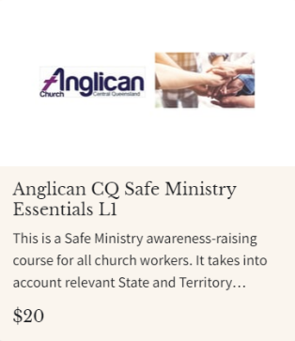

Level one must be completed by all staff & volunteers.

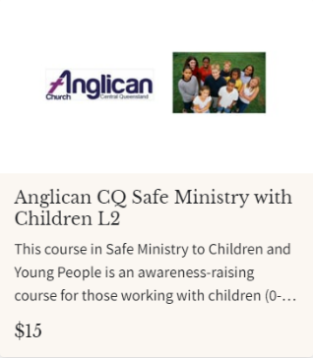

Level two must be completed by all Parish Council, Warden, Lay Leaders, Clergy and anyone involved in ministry to children.

- Email evidence of completion
Please email confirmation of completion to safeministry@anglicanchurchcq.org.au

For group facilitation or any questions concerning Safe Ministry training Please call the office on 07 4927 3188

