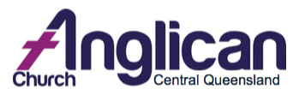
Safe Ministry Training
Refresher Workshop
This awareness workshop is intended to provide you with up-to-date information on Safe Church policies and procedures.
A workshop for all church workers who have previously completed the full training: Clergy, Parish Councilors, Wardens, Lay Ministers, Youth and Children’s Leaders, Pastoral Carers, etc.

This course will cover:
- duty of care, codes of conduct, positional power, transparency and accountability
- protecting vulnerable people including children at risk of harm- definitions, indicators and response procedures
- information about training, recruiting and supervising leaders

For the next available date
please contact:

(07) 4927 3188

- how to establish and run safe church ministry programs including risk management

For more information contact:
Diocesan Safe Ministry Training Officer:
Rev Jan Robinson (07) 4927 3188

Morning tea, tea, coffee and water supplied.

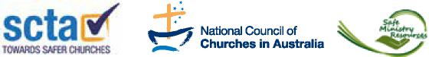
This workshop is an NCCA-SCTA endorsed workshop run by Safe Ministry Resources

